Victorian style doors

Meta Title,Meta Description ,Slug highlighted in Red
https://docs.google.com/spreadsheets/d/1lm0K66bFpzM6uJls08fmEoVcqNtQS23wXS-o5Z2fkSw/edit?gid=479815056#gid=479815056

Victorian style doors

Discover Victorian style high security front doors by Secure House
Victorian doors by Secure House are the most advanced front door solution on the market today. Victorian doors feature all the design benefits of a timber door plus they have all the benefits of a steel door. All the materials that go into our products are the very best available. Our doors are the marriage of artistic design with technical know-how.
At secure-house.co.uk, we offer a wide selection of Victorian front doors coming in a variety of different colour schemes, designs and stained glass decorations, perfectly fitting the different tastes of our clients. When looking for an option that best fits the home of your interior, you should look for an option that not only continues the theme of your interior, but enhances it in a certain way as well.
Some door variants invoke a sense of luxury as magnificence, meanwhile other variants are designed to make a house look as an absolute stronghold of security.

Secure interior and exterior

Victorian doors
Victorian doors are special in the way that they combine timeless styling along with sturdiness and functionality. Despite their old origins, it’s unlikely that they will go out of fashion any time soon and will continue to act as important parts of your home design as well as security setup. Here at secure-house.co.uk, our range of Victorian doors allows you to choose from the finest of finishes, colour schemes as well as a wide selection of wooden materials.
Whether it’s oak, pine or any other type of wood that’s more to your liking, we guarantee that you’ll find the best set of Victorian doors that perfectly fits your home according to your preferences.

Main features of Victorian doors
Just like any other types of doors, Victorian variants can come in various styling options, sizes and shapes, however, there are some key features that make them a distinctive option from other styles of doors.

Door with glazed panels
One of the most distinct features found on exterior Victorian doors is glassware which is not only important in the manufacturing process itself for the sake of sturdiness, it can also help as an additional means to create unique ornamentation and give more natural light to the home. The most common form of glass used is stained glass, which is often incorporated into the door panel.
Quite often, to add that Victorian feel, the glass structure will also feature a distinct colour scheme and other ornamental drawings. Sometimes, the glass panels are placed at the top of the door structure. This allows sunlight to come in from the outside and illuminate the interior of a home in a unique way.

Panelled door
Another distinct feature of external Victorian doors are the door panels themselves, which help invoke a sense of presence and luxury to one’s home. Combine that with a matching color to your interior and a unique panel decoration and you have yourself a set of secure and distinct looking doors. Most commonly, you’ll have a four-panel design being used, with glass extras as mentioned earlier.

Interior door elements
In terms of its interior design, Victorian glazed doors are all about security and sturdiness while maintaining a unique look that’s common for the style. Apart from the wood itself, which is a key door component, we usually see brass being used for locks, finger plates as handles. It allows not only to maintain the level of durability of the frame but allows for a unique design. This is essential for any Victorian internal doors, since it helps reinforce the frame and make sure that the glass decorations fit perfectly.

Victorian door materials
Victorian pine doors
One of the most popular selections for materials for a Victorian house front doors is pine. It’s main advantages offered are of course it’s fairly lighter weight when compared to hardwood alternatives, making for easier daily operation.
Another advantage for customers is the fact that pine is much easier to manufacture, often resulting in a significantly lower price when compared to oak doors.
This is essential, since pine is by no means a bad alternative in terms of structural strength.
Finally, pine doors maintain a unique aesthetic both when buying already pre-made door sets or customizing a set to your liking.
Victorian oak doors
Oak is, of course, the most common material when it comes to a Victorian wooden front door that has its own set of unique benefits.
First of all there is the unmatched sturdiness and protection for your home that such wooden Victorian period front doors can offer.
Just like with pine doors, oak variants offer their own unique luxurious and cozy look, however, one could argue that oak doors offer a higher sense of security and nods back towards more of a traditional look.
While a bit more expensive, they still remain a popular and desired option for both customizable and pre-made Victorian internal doors.

Victorian door gallery

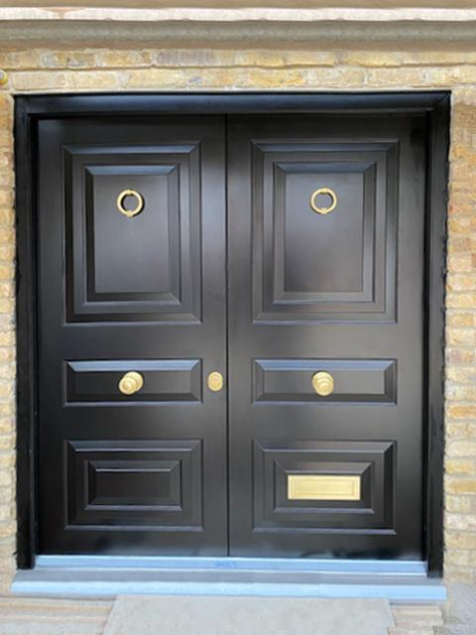
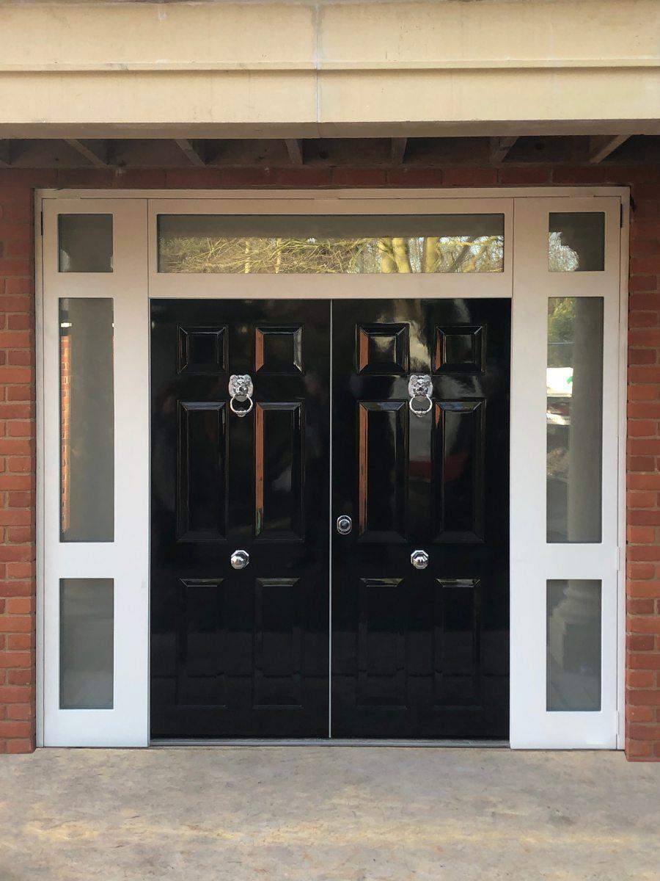
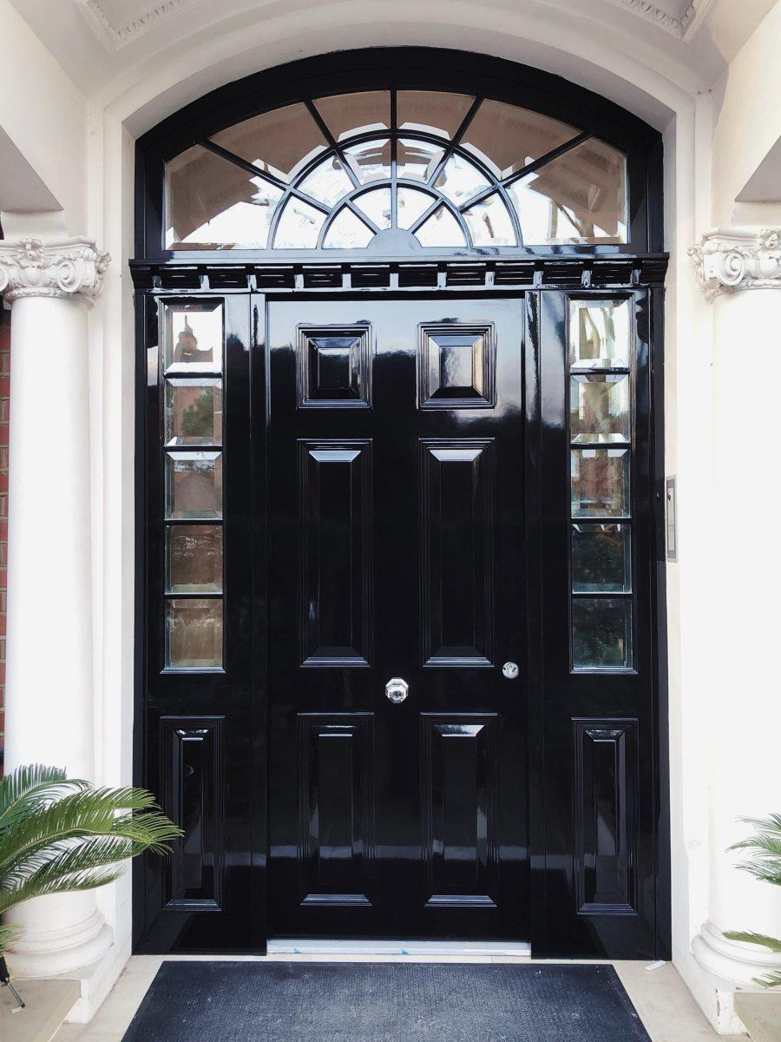
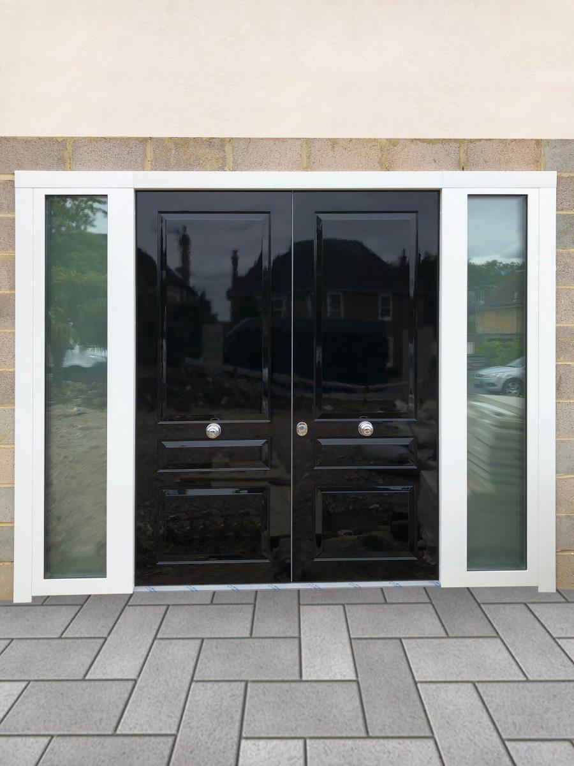
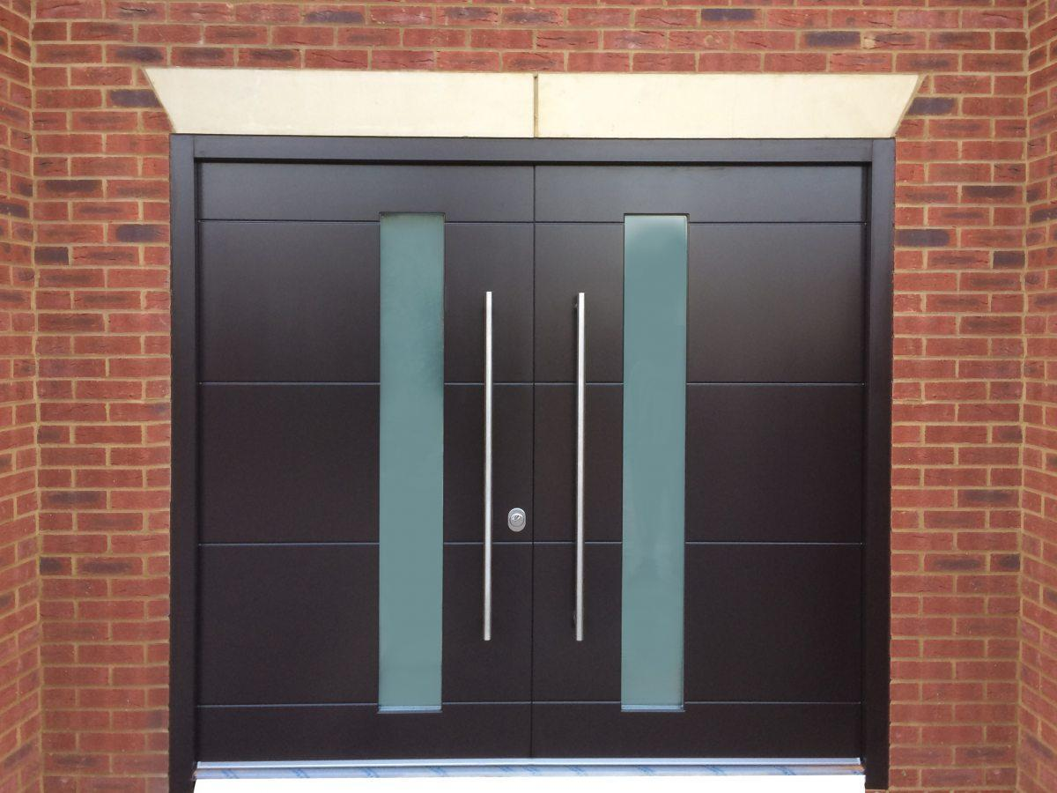
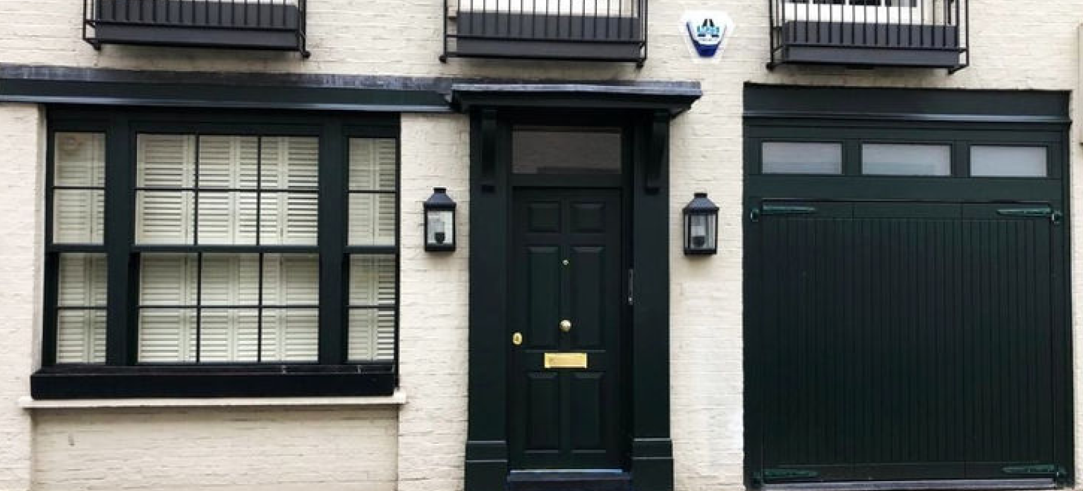

Frequently asked questions (FAQ)

Why choose Secure House Victorian entrance doors?
At our shop, you’ll find a wide selection of interior security doors, offering a unique aesthetic, while at the same time maintaining that sturdiness and security capabilities as mentioned earlier.
We pay special attention towards ensuring that every purchased Victorian house door is just as envisioned, both in terms of functionality and visual looks.
We believe that any Victorian door solution should be affordable to anyone which is exactly why we offer a wide selection of products aimed to satisfy every front door security need of our customers.
If you have any questions concerning our products, feel free to contact our team and we will get in touch as soon as possible.

Historical significance of Victorian interior doors
You may be wondering, what’s all the fuss about Victorian style security doors and why are they such a popular choice for a secure and stylish solution for any house? Well, it all has to with the rich history from which these door solutions come from.
As you might already know, the Victorian style has graced households for over a hundred years now, which further proves it standing the test of time and still being loved by people all around the country.
The Victorian era, which is said to last from 1837 to 1901, was all about grandeur, luxury and magnificence. It’s no surprise that the same feeling moved on towards the doors found in British households.
In a way it was a means to make a bold statement about your home and to showcase to anyone looking at your victorian style front door the immense and strong presence of your home.
During this era, there was an increase in social mobility as well, meaning people paid more attention to first impressions made on others. This influenced the way they dressed, acted, and of course, the way they presented their homes to others.
A Victorian style door followed suit with the mentioned elements of prestige and setting the tone for others.
The most common features back then were brass elements and door furniture as a means to enhance the door frame panelling, while glazed doors which featured intricate glasswork, contributed not only visually, but also by adding lighting through the front door. This was a very common sight for Victorian period entrance doors.
The style itself changed other areas such as general architecture, new inventions and so on, all following the same formula of extravagance, but at the same time, not letting the importance of functionality slip through.

What is considered a Victorian door set?
A Victorian door set is considered to be a distinct style of door that originated during the period from 1837 to 1901. Most common features of such a door set worked towards creating an eye-catching, extravagant look which was often achieved with the help of stained glass, glazing elements and clear-cut wooden door panels.

Does a Victorian door feature a paint scheme in a traditional look?
Yes they do. Selecting an appropriate colour which enhances the look of one’s front door and helps to continue the theme of the interior was a common site back then and remains to this day.
It’s fair to say however, that the colour options for a paint scheme have increased massively these days, which adds to the personalization of your new front door.

Can a Victorian door really offer the right amount of security for your front or internal doors?
They do. Arguably the main reason for this is the fact that all Victorian external doors are manufactured from very strong wooden materials which are further enhanced during the manufacturing process with additional elements for panels amongst other parts.

What elements are key in the door manufacturing process?
Most strong internal doors are made from a wooden base from either pine or oak, with furniture elements made from brass or other metal. In terms of additional enhancements, stained glass may be used to create a set of glazed doors which allows additional natural light to come in from outside.

Industrial Style Door
https://web.archive.org/web/20250810170654/https://secure-house.co.uk/doors/industrial-style-doors/
Meta Title,Meta Description ,Slug highlighted in Red
https://docs.google.com/spreadsheets/d/1lm0K66bFpzM6uJls08fmEoVcqNtQS23wXS-o5Z2fkSw/edit?gid=479815056#gid=479815056

Industrial style door

Stylish & Durable Industrial Style Doors for Modern UK Living
Industrial style door ‘steels’ the show. New design additions
to our steel portfolio that offer an industrial look
View gallery
Bespoke design, made to measure products
Material thicknesses
up to 5 mm
Solid hot rolled
steel profiles
Available in RAL
colours
FD30 fire
resistance
Minimalistic
profiles
Window and door elements made from glazed slim steel or bronze profiles are ideal not only for renovated historical buildings, but also for top-of-the-line residential and commercial buildings. These timeless windows and doors are sure to make any residence stand out. Due to the unparalleled structural strength of these steel frames, they are also an excellent choice for modern buildings with tall and wide windows.
Steel is an excellent choice for manufacturing fire doors due to its reliable performance under fire conditions. When combined with suitable fire-resistant glass, it forms an effective defense against both fire and smoke.
Thin steel frames not only does the new door look effortlessly stylish, but it is also incredibly secure with security glazing and state-of-the-art entry system.

Read more

Design
Typified by a very slim profile frame that forms a grid-like finish for doors, windows and room dividers, our steel fire proof products will not only open up a space but totally transform it into something completely contemporary with bundles of natural light. They’re ideal for use across a wide variety of buildings too, from refurbishments and new build homes to listed buildings and properties located in conservation areas.
Having such a narrow and sleek steel frame, the doors and windows allow an abundance of light into any home or property. As a result, they can really open up any area in a home or residential building to give extra space and a real feeling or openness.

Read more

Crittall style doors –

elegance and heritage
Crittall style doors owe their name to the British company “Crittall,” which pioneered this design in the early 20th century. Primarily crafted from hot rolled steel sections, these heritage bifold doors and hinged doors are renowned for their remarkable durability and robustness.

Read more

Industrial style

doors – ruggedness and versatility
Industrial style doors, also known as a heritage style door, draw inspiration from the raw, functional designs found in factories and warehouses. Their origin lies in the necessity for durable sliding doors in these heavy-duty environments.
Over time, the rugged charm of these doors, including steel and aluminium french doors, transcended their utilitarian beginnings, finding a place in commercial and even residential settings, as both internal and external doors. Industrial doors boast a diverse range of materials, from galvanized steel to aluminium and wood.

Read more

Why fire rating is so

important for a set of

internal doors
Not everyone pays attention to the manufacturing and installation process as well as the materials that door contractors use in their product, even though, we reckon, it should be one of the most important points when considering your security door solution.
At Secure House, we ensure that every single one of our window and door solutions offered are designed with careful attention to detail, ensuring not only proper, but more importantly – correct fire protection for a fire door.
In the case of an accident your set of doors or windows will be your main means of preventing the spread of fire to your neighbouring rooms or the inside of the building overall, which can happen in minutes if not seconds, and can also act as a possible escape route.
Our windows and doors feature a reinforced steel frame with additional components such as cladding, seals as well glazing all aimed at providing you with the best possible level of protection. This new lineup can be made to be FD30 fire regulations compliant.

Crittall style doors vs.
Industrial style doors.
What are the key differences?

Material

Design

Origin

Transparency

Installation

Cost

Industrial style doors gallery

Frequently asked questions (FAQ)

Why industrial doors are often called Crittall doors?

What materials are used by Secure House to manufacture their window and door elements?

What types of doors does Secure House offer?

What is a distinguishing feature of the W20, W40 steel fire doors and windows?

What is the fire protection category for Secure House’s industrial doors?

How can one get in touch with Secure House to know more about their products?

Does Secure House offer crittall style doors?

What kind of response did Secure House receive after adding a range of industrial proof doors, windows, and room dividers to their steel portfolio?

For what types of buildings are Secure House’s glazed slim steel or bronze profiled windows and doors ideal?

Why is the fire rating important for a set of internal doors?

What are some of the most popular finishes for Secure House’s ironmongery handles and door furniture?

